Camcare holds a monthly BBQ for the Boroondara community in the garden at our office in St John's Avenue, Camberwell. All welcome.

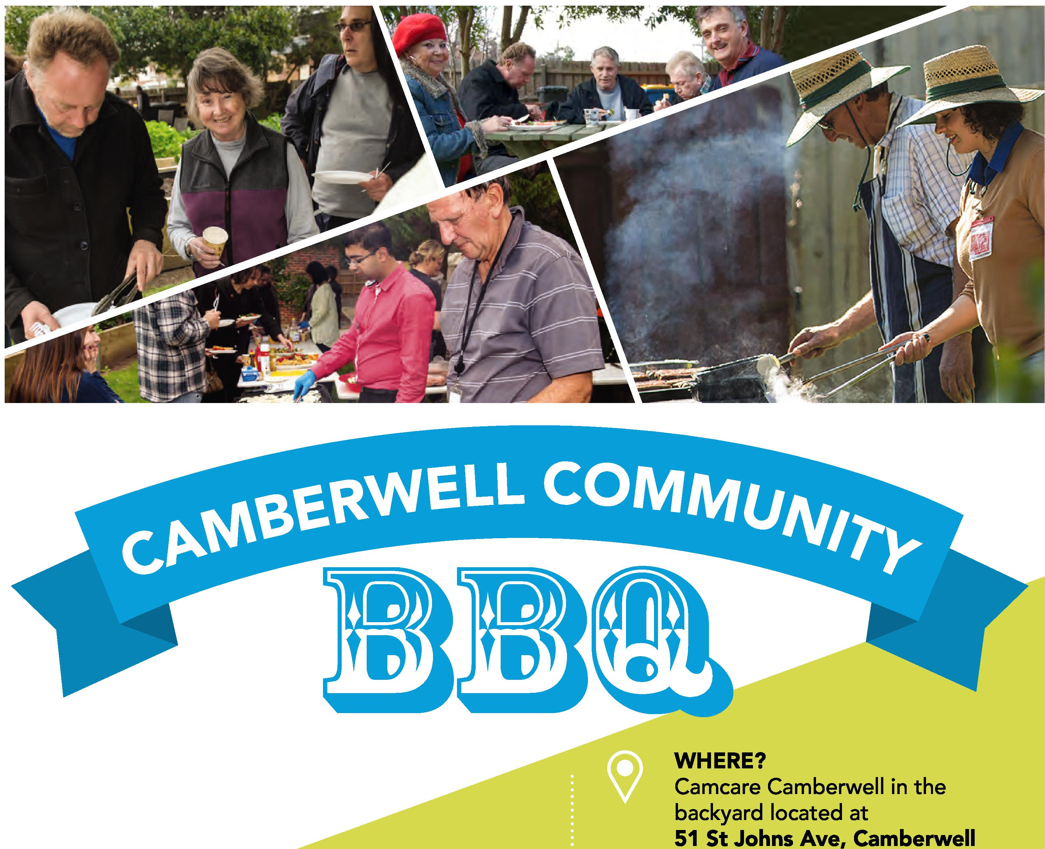
WHERE?
Camcare Camberwell
51 St Johns Ave, Camberwell
-4¹
Come in for a chat and a yummy feed.
This is an all-weather event — rain, hail or shine!
WHEN?
12pm on the last Thursday
of every month (except December)
UPCOMING DATES FOR 2019

31 October 2019
28 November 2019
19 December 2019

Time : 12pm to 2pm

For further information contact (03) 9831 1900

